**Description**

The Super Predator Gas Separator from Advanced Energy Solutions is a downhole gas separator so far used primarily in rod pumping systems, similar in function (if not form) to a poor boy or Mother Hubbard separator. It works something like a series of poor boy style separators, stacked one on top of another, set up such that the chambers are supposed to operate in parallel. It does require a packer at the bottom of the tool, more like a packer-style separator. The diagram below shows the main pieces of the chambers, and gives some idea of how fluids move through the tool. Fluids enter at point 4 (which also allows gas to escape on the downstroke). Liquids move through point 7 into the dip tube. Solids in each chamber are supposed to collect at the bottom of the chamber, and through the ‘chute’ noted in point 6, to the bottom of the tool. Gas, as noted earlier, can rise out of the inlet ports (like a conventional separator). It can also rise through the ‘highway’ noted in point 5 to the top of the tool at point 1, where it should vent back into the casing annulus. The overall tool will have a large number of these chambers, depending on the desired capacity of the separator. The diameter of the port noted as point 7 is supposed to meter liquids into the dip tube and force the chambers to operate in parallel.

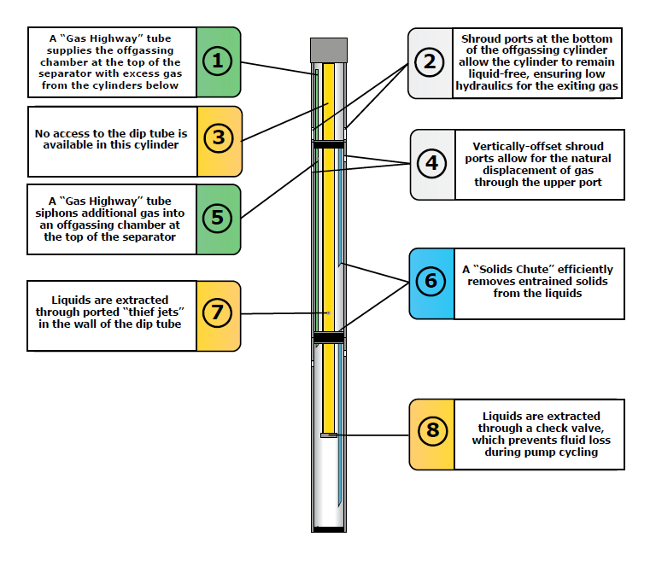

Picture courtesy Predator Tools

**Summary**

We installed one as a trial on the Adams 4231 in March 2019, in the East Wolfberry asset, and have monitored it closely for production and performance. The well was judged capable of producing something like 400 bfpd. In actuality, the well has hovered around 250 bfpd of production with this separator, with consistent incomplete fillage and high pump intake pressure. The well is on a VSD.

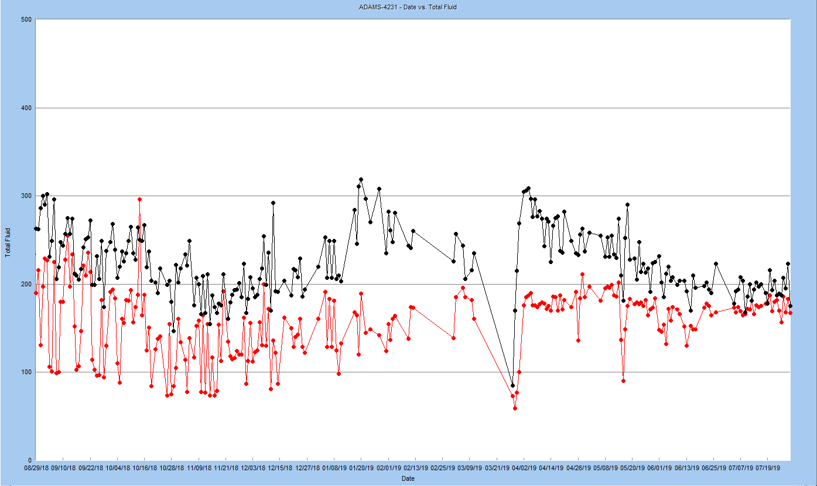

Predator Installed

Gas

Total Liquid

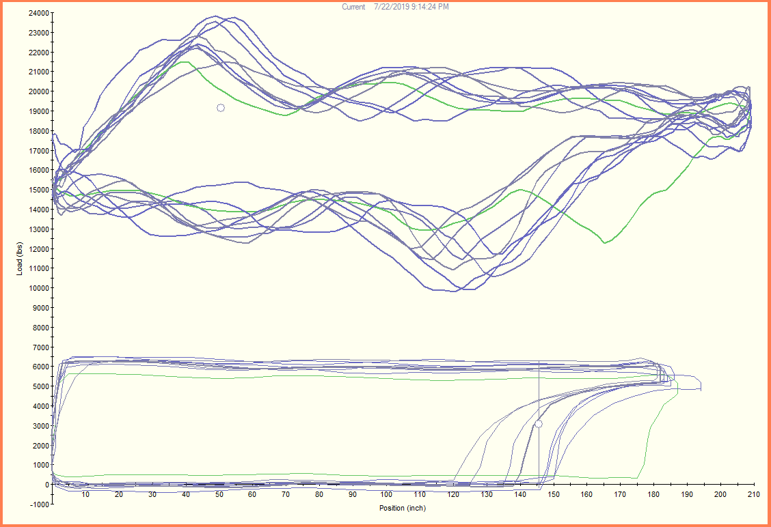 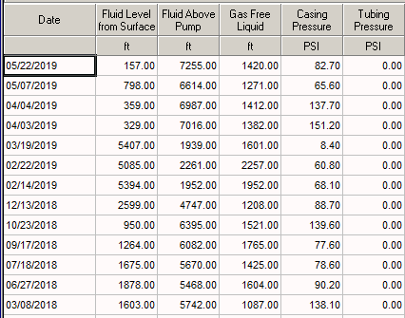

We have adjusted the pump speed and setpoints, but although the fillage moves around in response to those changes, there was little change in production or performance.

**Comments and Conclusions**

The diagram above describes only how the chambers (as the primary point for phase separation) works – there are a variety of ancillary parts to the tool that vary depending on the circumstances found in a particular well.

Based on the trial to date and conversations with the vendor, we believe that the mechanism in the design that is intended to distribute fluids across the chambers (so they operate in parallel) does not work as intended, such that only the top two or so chambers is moving fluids (both liquids and gas) to the pump intake. With that, the capacity of the system is limited to that of the ‘active’ chambers.

At this point, with the data we’ve seen to date, it is not a tool we would recommend. Regardless of the casing size, there is more gas separation capacity in other tools than in the Predator.

If you are interested in further information, please contact any of the following:

Corey Hardegree ([Corey_Hardegree@oxy.com](mailto:Corey_Hardegree@oxy.com))

Anthony Allison ([Anthony_Allison@oxy.com](mailto:Anthony_Allison@oxy.com))

Chris Humphreys ([Christopher_Humphreys@oxy.com](mailto:Christopher_Humphreys@oxy.com))